STATISTICAL FUNCTIONS

NOTE: Statistical functions calculate values related to statistical distribution and probability.
These function categories applied in new measure only why because statistical function is a scalar function and will returns as single value parameter.
Input Data: (create table with the name of – statisticalfunction)
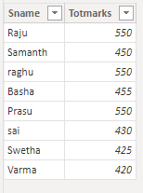

1)RANKX: By using this we can find the raking of a number.
Syntax: RANKX(<table>, <expression>[, <value>[, <order>[, <ties>]]])
NOTE: This function can apply in numeric/decimal/date time datatype columns.
By using this we can easily compare the products, salespeople or anything else that you want to evaluate the performance.
<table> -- given table name
<expression>--given particular column name
<value> ---is not necessary, not given any value.
<order>given asc/desc order, which u want
<ties>contain two values 1) dense or skip-default skip.
Diff between Rank and Dense Rank:
Dense: will not skip between rank numbers.
Skip: skip between rank numbers.
“For example, if five (5) values are tied with a rank of 11 then the next value will receive a rank of 12(11+1).
The next rank value, after a tie, is.
For example, if five (5) values are tied with a rank of 11 then the next value will receive a rank of 16 (11 + 5)( the rank value of the tie plus the count of tied values)
RANKX will not support Direct Query.
If we can find rank for more than one column, can use that cross join.

Dax Function:
NOTE: First of all, create a measure for total marks because it’s not working for rank in total marks column, its working rank for measure of column name. Thats why we can create a measure of total marks.
1) Measure of Totmarks = SUM(statisticalfunction[Totmarks])
Output:
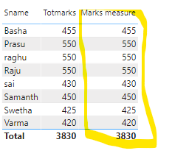
NOTE: now rank will apply in marks measure column.
- Rankx = RANKX(statisticalfunction,[Measure of Totmarks],,DESC)

Output:
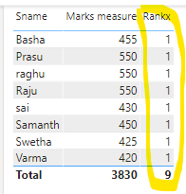
NOTE: This is not valid ranks that’s why we can use “All” function, using that can remove the filter.

3) Rankx = RANKX(All(statisticalfunction),[Measure of Totmarks],,DESC)

Output:
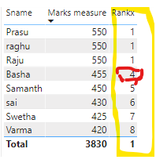
NOTE: By default, it will take skip tie value. It’s not better the rank value. Why because after 1 rank next rank is 2 but in this rank is 4.so will use that “DENSE” tie value.

4) Rankx = RANKX(ALL(statisticalfunction),[Measure of Totmarks],,DESC,Dense)

Output:
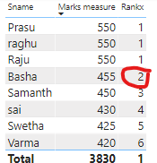
NOTE: Observe that previous report, in that 4th rank will be changed as 2nd rank by using “Dense” tie value.
For example, we can take one slicer, using slicer based on selected “sname” ,I want to display ranks, but in that not provided correctly ranks.so that’s why we can use in that “All” – “Allselected”.

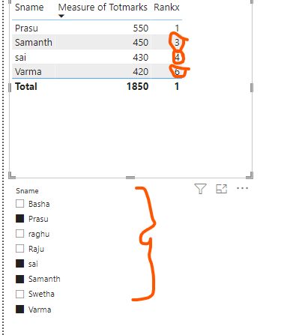

5) Rankx = RANKX(ALLSELECTED(statisticalfunction),[Measure of Totmarks],,DESC,Dense)
Output:
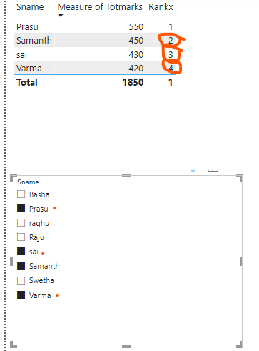

NOTE: Observe previous and this report.

Finnaly Dax Function:
Rankx = RANKX(ALLSELECTED(statisticalfunction),[Measure of Totmarks],,DESC,Dense)
Output:
